All meetings are normally open to the Public and Press

4th December 2023
To: All Members of Witham Friary Parish Council, County Councillor Clarke.
Dear Councillor
You are summoned to a full council meeting of the Witham Friary Parish Council on Tuesday 9th January 2024 7.30pm. The meeting will be held at Dovecote.
The meeting will consider the items set out below.
J A Gregory

Jennifer Gregory
Parish Clerk
A G E N D A
Meeting to be suspended for a public session to enable the electorate of Witham Friary to ask questions or make comments. Questions not answered at this meeting will be answered in writing to the person asking the question or may appear as an agenda item for the next meeting. Members of the public are asked to address the Chair with their question and please restrict their comments and/or questions to 2 minutes on any relevant issue. Member of the Press and public will be excluded if the Parish Council by resolution enters a confidential session

01.23/24.01 Apologies for absence and to consider reasons given
1.1 Council to receive apologies for absence and, if appropriate, to resolve to approve the reasons given.

01.23/24.02 Declarations of Interest and Dispensations
2.1 Members to declare any interest they may have in agenda items in accordance with the Council’s Code of Conduct.
2.2 To receive written requests for dispensation for disclosable pecuniary interests.
  - To grant any dispensation as appropriate.
01.23/24.03 Minutes of the previous meeting held
  - To confirm and sign as a correct record the minutes of the meeting held on 12th December 2023

01.23/24.04 Report by County Councillors

01.23/24.05 Planning Applications for consideration
Nothing to report.

01.23/24.05 Finances
5.1 To agree schedule of payments as indicated below:
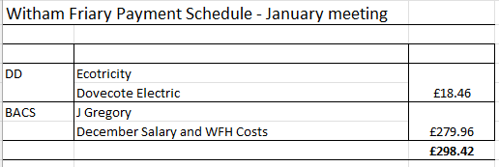

5.2 Financial Update including cashbook figure as at 31.12.23 £34301.85
5.3 Precept request complete

01.23/24.06 Reports
6.1 Chairman’s Report including future meeting venue
6.2 Highways (FN)
  - Communications (MF)
6.4 Recreation Ground (WS/JK)
  - Play Patch (JK)
  - Footpaths (LS)
  - Biodiversity Officers (LS MF)
6.8 Dovecote – Progress update

01.23/24.07 Network Rail update (MF)

01.23/24.08 Other business referred to the Clerk

01.23/24.09 Date of next meeting
9.1 February meeting 13th
Close

