M I N U T E S
Of Witham Friary Parish Council
Held on Tuesday 9th August 2022 at Witham Friary Village Hall

Present: Chair W Sheppard, Cllrs J Knowles, F Nicholls, L Sewell

Also Present: County Councillor B Clarke, J Gregory Proper Officer, plus 3 members of the public

08.22/23.01 Apologies for absence
Cllr Brooke had given apologies for medical reasons, District Cllr Gay also provided apologies on medical grounds
Resolved: Apologies accepted from Cllrs Brooke and District Cllr Gay for the circumstances noted.

08.22/23.02 Declarations of Interest
Members were asked to advise any Declarations of interest in today’s agenda items or any pecuniary interests in line with Councils’ Code of Conduct.
Resolved: It was noted that no declarations, pecuniary or otherwise were received.

08.22/23.03 Minutes of the Previous Meeting
To receive the minutes of the meeting held 14th June 2022
Resolved: Signed by the Chairman as a correct record in the presence of the meeting.

08.22/23.04 Matters Arising
None

Public Participation
Items raised included Witham Water and Churchyard, both of which would be included in the various reports later in the meeting.
County Cllr Clarke gave a brief of the Unitary situation indicating that the shortfall in the County budget was now standing at 48 million.

There had been an ecological emergency in South Somerset with species disappearing.

LCN’s were discussed and Parish Councils urged to become involved.

There was a Somerset Communities Fund who had stepped in to cover a closed fund operated by EDF.

Bus partnership was encouraged to get involved with however this had been previously considered in detail with any bus service not the most convenient.

08.22/23.05 Planning Applications
Nothing to Report

08.22/23.06 Finance
6.1 To present current financial statement and balance on accounts – Balance on accounts showing as £42034.90 (bank reconciliation attached)

6.1 To agree schedule of payments as indicated below noting that July payments had been agreed by email following the postponement of the meeting.

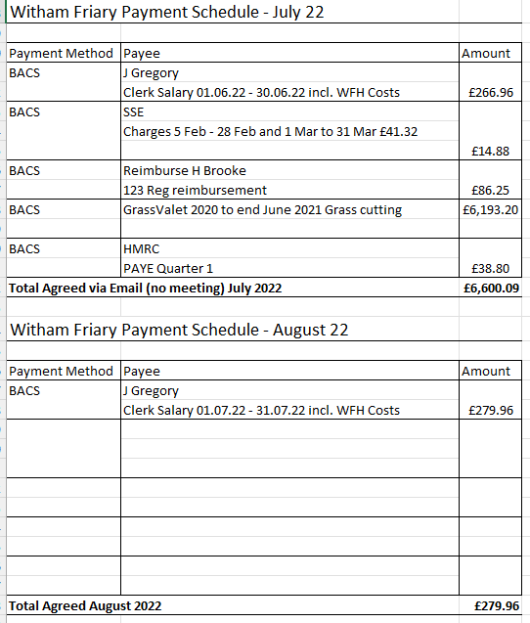
In addition to the above the Clerk reported that election fees of £1028.24 had been sent by post to “rough stubbs” unsure why as the clerk’s details had been changed with Mendip DC previously. There was also an invoice from Steve Orr of £140 (of which we previous agreed £250 a month) and payment for the ROSPA Annual Inspection of £168.
Resolved: Payment schedule approved along with extra payments required.

6.2 Current bank reconciliation at the end of July amounted to £36953.73

6.3 The Clerk asked whether Cricket were due to make a contribution to extra cuts and rolling.
Action: Clerk to provide a breakdown as Cllr Sheppard was due to meet with both Cricket and football.

08.22/23.07 Reports
- To receive Chairman’s Report
In the absence of Cllr Brooke, Cllr Sheppard had nothing to report. Cllr Knowles gave an update on Cllr Brooke who was improving but was not ready to enter fully into being Chair. Well wishes were expressed from the Parish Council on a return to good health.

- Cllr Nicholls report on Highways
There had been white lines around the bend but there could do with a white line around the kerb to Manor Farm. Chevrons (not asked for) had been placed at West End. Verges remained uncut in several places causing some concern for safety.
Action; Cllr Ferrari would look at with Sara Davis in traffic

- To receive Cllr Ferrari report on Communications
There was discussion about further communication regarding water usage on the facebook page.

- To receive Cllr Sheppard report on the Recreation Ground
Cllr Sheppard is due to meet with representatives from Cricket and Football and to look at storage issues for the two groups.

ROSPA gave a report on the recreation ground and despite moving the cricket nets for some time the day before the inspection they had been moved back so the problem had been solved but then appeared again in the inspection report. We now know however that the problem can be managed. ROSPA advised on more fencing and Cllr Sheppard would look at Grass Valet and the issue of pump track maintenance.

- To receive Cllr Knowles report on the Play Patch
ROSPA had sent a report however this had not been circulated as Cllr Knowles was noting actions. However from previous inspections actions had been in hand with Steve Orr completing some work. The see-saw seats were complimented on.

Cllr Ferrari stated that the metal slide was incredibly hot during this heatwave and it was agreed that it be taped off for a temporary period whilst we wait for cooler weather.
Action: Cllr Ferrari to tape of slide (temporarily)

- To receive Cllr Sewell report on Footpaths
Cllr Sewell had arranged for a new Bridleway sign but Council needed to agree where it goes. The original sign would be refurbished and Conker Club asked for support.
Action; Cllr Sewell given permission to decide on location for sign

Holt Farm had 3ft electric fences across the footpath, whilst Claire Askins from SCC had walked this route it was still felt that there should be insulation / or similar on electric fences that crossed the footbath
Action; Cllr Sewell to provide representations to CA at SCC

Gibbons Farm to Hermitage now had a permissive footpath installed. It would be a years’ trial to encompass all seasons as aspects of the new path would get very wet in winter. It was suggested in view of permissive footpaths being withdrawn that this be reviewed in approximately April next year.

There had been a sub-group formed to look at footpaths in the area. As a result the Tyne Mead track – although not allocated as a public footpath but part of the old footpath line had a padlock. A conversation with the landowner was considered necessary however investigations had drawn a blank on who this was therefore it was suggested that a fee to the Land Registry be paid to ascertain ownership
Resolved: Payment agreed of £29 to Land Registry

A similar situation existed with the Old Piggery with dumping of waste. There was suggestion it was owned by a builder but now had a large amount of asbestos on site.
Resolved: Payment of £29 agreed to ascertain ownership

It was reported that stiles had been replaced – one on the way to Truddoxhill with a metal swing gate. In fact 3 or 4 along this line needed to be done and had been requested. A watching brief on action from SCC as to whether this request would be actioned.

Cllr Nicholls stated that there had been 2 incidents of barbed wire being cut, the first at Redgate next to the stile and the another at Scout ground last Saturday where cattle got out causing a potentially dangerous situation with cattle approaching Trout Pond Swamp. County Cllr Clarke stated that he had known walkers to cut barbed wire as they don’t like it along footpaths to make a point. It was agreed that more awareness in the village was needed of potential situations if barbed wire was to be cut
Action: Facebook entry to be made making people aware

- To receive Cllr Ferrari report on Churchyard
Cllr Ferrari. Ann Dalgety and George met with a village group regarding the condition of the churchyard. Agreement had been reached for increased biodiversity and acknowledgement of active graves being overgrown was distressing to relatives. The original wording from the Diocese wasn’t helpful in stating “rewilding” of churchyards. The future of the graveyard looks brighter with help provided to maintain on a 2 weekly basis and consideration given to a grant to help with the running costs of machinery and providing some biodiversity in planting wild daffodils and native bluebells. The Clerk felt that perhaps the Council should consider a Grant Funding Policy – one to be equitable to all groups in the village and secondly for budget and control purposes.
Action; Clerk to action a policy for approval and for the Church to consider an application

08.22/23.08 Network Rail
Nothing to report. Emails of introduction had been sent and a request for any strategy regarding ash die back to be provided.

08.22/23.09 Witham Water
With an opening comment from Cllr Nicholls that the system, despite the heatwave was coping well a slightly contradictory message had that minute been received. With reports of the water table low and springs starting to dry up the situation was only just coping. The village was urged to be careful with its use of water. Whilst WW had not introduced a hosepipe ban there needed to be more mindfulness around water usage and whether washing the car every week with a hose in a heatwave the right thing to do.
Action: Notice to be sent to be very vigilant with water on social media

It was stated that the History Society would be approaching individuals for a history of Witham Water, Cllr Nicholls would be approached. It was felt that this would be helpful in educating villages on how the system works and leaflets could be left in the pub and other locations.

08.22/23.10 Other Council business
Storm Sewer Overflow
Cllr Sewell that the Tyne Mead sewer overflowed 9 times in 2021 for a total of 62 hours. This was obviously detrimental to the quality of water in the river and the water quality noted as “environmentally poor”.
Action: Comments noted

Facebook Page
Following training it was suggested that the Parish Council have its own Facebook page. Perhaps something to tie in with the website issue. It would also be a good way of tying in with what villagers want from their Parish Councillors.
Action; Matter deferred to next meeting

Dogs on Recreation Field
Roxy had been approached to design more signs following more dogs being noted as on the Recreation field. Action: A follow up with Roxy would be instigated in due course following the school holidays.

Biodiversity Officer
It was felt that with MDC’s action on climate change and reiterated by tonights comments of ecological emergencies within the County there should be a Biodiversity Officer.
Resolved: This was agreed with Cllrs Sewell and Ferrari sharing the post

Website Update
A sub-committee of three had looked at one of two suppliers regarding moving the Village website to a Parish Council website. There had been test sites and videos of “how to” viewed and the system played with. The cost was in the region of £500 set up and £250 a year for maintenance and support. The next stage would be to plan the framework of how the site needed to look and in terms of timeline the Council were looking at around 6 months to move completely across with a decent amount of history and archive.
Resolved; The Clerk authorised to progress to the next stage noting one abstention from Council.

Flood Defence Report
A report from Cllr Ferrari had been circulated and the Council noted the concerns detailed.

Distgen
Cllr Ferrari had contacted Distgen to look at the process of a wind-turbine. She stated that the starting point would be to look at appetite before inviting landowners and Directors of Distgen to discuss.
Action; It was agreed for Cllr Ferrari to make initial investigations.

08.22/23.11 Any other Business
A meeting had been held regarding Long Ham involving Ann, Cllr Sheppard, Simon Nash and Charlie with the outcome being that the way forward was still be decided and reports on the area awaited. The area had however been cut and tidied up. It was reported that a open meeting at the Village Hall was scheduled for October – date TBA.
Action: Clerk to add Long Ham as an Agenda report for future meetings.

08.22/23.12 Date of next meeting
13th September 2022 – 7.30pm at Witham Village Hall.

Meeting closed at 9.08pm

A signed copy of the minutes can be viewed by arrangement via the Parish Clerk.

